- INTRODUCTION
overview
    - Description of the project

ProjectDescription:
Fashion Haven, an online retail store, leverages Zoho Books to manage their inventory and track sales. They can generate invoices and manage customer payments seamlessly. Zoho Books also enables them to reconcile bank transactions and generate financial reports, helping them make informed decisions about their business..
Fashion Haven is a Private Limited company also registered under GST in Tamil Nadu. Fashion Haven is a retailor of various lifestyle products in wholesale and retail, it has a wide range of customers (B2B & B2C) all over the state and it procures from various suppliers in the state. It operates at a Gross Profit margin of 50%.

PURPOSE

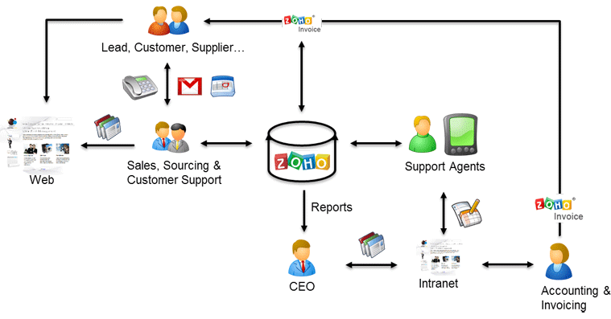

- Problem definition & design Thinking

Empathymap

BRAINSTORM

F

Purchaseorder:

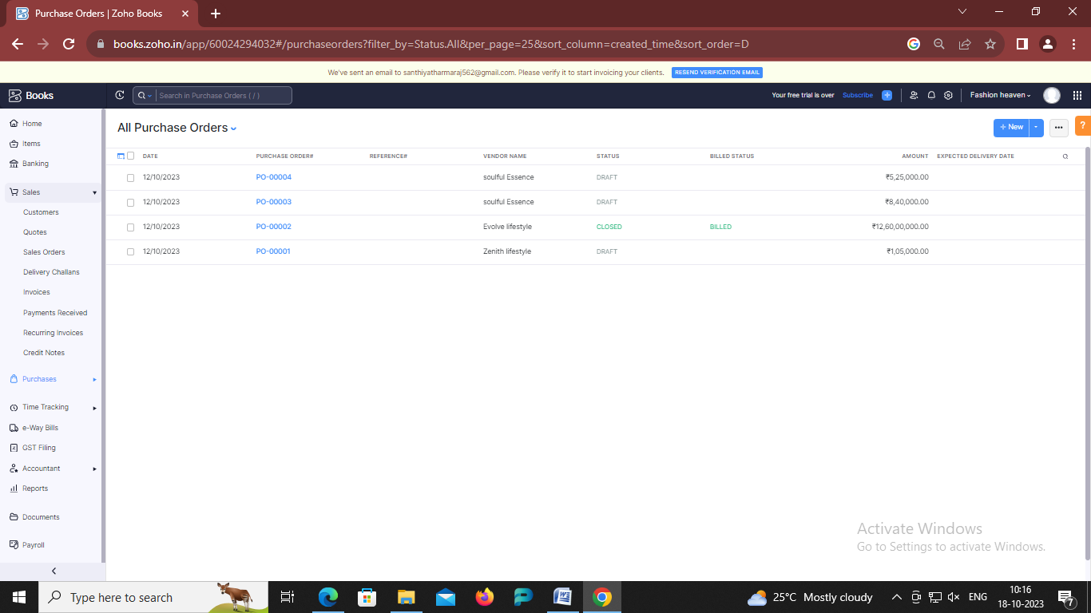

ADVANTAGESOF FASHION HEVAN:
Advantages of being fashionable
The one significant thing about fashion is that it is a useful tool to build confidence. wearing different designer clothes or dresses ins insert a feeling of self-confidence. And also feel confident and independent in your choice.
DISADVANTAGESOFFASHION HAVEN:

Ensure all the factories you work with have strict policies around worker hygiene and safety.
- Use 3D design solutions to test samples for fit, design and quality before manufacturing physical pieces to minimize waste.
- Use less resource-intensive sustainable materials that are not as harmful for the environment.
- Make use of analytics and production intelligence to forecast demand and avoid overproduction.
- Increase transparency in your supply chain by using production tracking software such as PLM and ERP to establish accountability

- APPLICATIONS:
FASHION HAVEN.
- Conclusion:
Conclusion Fashion can be overlooked and downplayed quite often. Fashion is so much more than just throwing on a pair of pants with a shirt. Fashion and personal style means something to people. Its a way of expressing who someone is or to prove themselves to others, its a womans vulnerability, style is something that is someones own and makes a person feel unique and individual. For as long as time can tell fashion has played a huge role in the world and its something people will never not need

- FUTURESCOPE:
Fashion Design is a three-year degree programme divided into six semesters and includes both practical and theoretical sessions. The Bachelor of Design (Fashion Design) is a three-year degree programme that is divided into six semesters. Fashion design is the process of creating clothing and accessories that are in keeping with the current designs and trends in the fashion industry. Students gain knowledge of various design patterns, materials and fabrics, as well as sequins and beads

- APPENDIX:

<!—savedfrom url=(0087)https://
<!github.com/asmku643mku643c1c31260/NM2023TMID22539/blob/main/profit_and_loss.pdf ◻

<html lang=”en” data-color-mode=”auto” data-light-theme=”light” data-dark-theme=”dark” data-a11y-animated-images=”system” data-a11y-link-underlines=”true”
data-turbo-loaded=””><head><meta http-equiv=”Content-Type” content=”text/html; charset=UTF-8”><style type=”text/css”>.turbo-progress-bar {

Position:fixed; Display: block; Top: 0;
Left: 0; Height:3px;
Background: #0076ff;
z-index:2147483647; transition:
width 300ms ease-out,opacity 150ms 150ms ease-in; transform: translate3d(0, 0, 0);
}

</style>

<link crossorigin=”anonymous” media=”all” rel=”stylesheet” href=”./NM2023TMID22539_profit_and_loss.pdf at main · asmku643mku643c1c31260_NM2023TMID22539 · GitHub_files/light-b92e9647318f.css”><link crossorigin=”anonymous” media=”all” rel=”stylesheet” href=”./NM2023TMID22539_profit_and_loss.pdf at main · asmku643mku643c1c31260_NM2023TMID22539 · GitHub_files/dark-5d486a4ede8e.css”><link data-color-theme=”dark_dimmed”crossorigin=”anonymous”media=”all”rel=”stylesheet”data-href=https://github.githubassets.com/assets/dark_dimmed-27c8d635e4e5.css><link data-color-theme=”dark_high_contrast” crossorigin=”anonymous” media=”all”

rel=”stylesheet”
data-href=https://github.githubassets.com/assets/dark_high_contrast-8438e75afd36.css><link data-color-theme=”dark_colorblind” crossorigin=”anonymous” media=”all” rel=”stylesheet” data-href=https://github.githubassets.com/assets/dark_colorblind-bf5665b96628.css><linkdata-color-theme=”light_colorblind” crossorigin=”anonymous” media=”all” rel=”stylesheet” data-href=https://github.githubassets.com/assets/light_colorblind-c414b5ba1dce.css><linkdata-color-theme=”light_high_contrast” crossorigin=”anonymous” media=”all”rel=”stylesheet”
data-href=https://github.githubassets.com/assets/light_high_contrast-e5868b7374db.css><link data-color-theme=”light_tritanopia” crossorigin=”anonymous” media=”all” rel=”stylesheet” data-href=https://github.githubassets.com/assets/light_tritanopia-299ac9c64ec0.css><linkdata-color-theme=”dark_tritanopia” crossorigin=”anonymous” media=”all” rel=”stylesheet” data-href=https://github.githubassets.com/assets/dark_tritanopia-3a26e78ad0ff.css>

<link crossorigin=”anonymous” media=”all” rel=”stylesheet” href=”./NM2023TMID22539_profit_and_loss.pdf at main · asmku643mku643c1c31260_NM2023TMID22539 · GitHub_files/primer-primitives-6143c8f97ed1.css”>

<link crossorigin=”anonymous” media=”all” rel=”stylesheet” href=”./NM2023TMID22539_profit_and_loss.pdf at main · asmku643mku643c1c31260_NM2023TMID22539 · GitHub_files/primer-d6dcdf72e61d.css”>

<link crossorigin=”anonymous” media=”all” rel=”stylesheet” href=”./NM2023TMID22539_profit_and_loss.pdf at main · asmku643mku643c1c31260_NM2023TMID22539 · GitHub_files/global-ab1c3e3e5644.css”>

<link crossorigin=”anonymous” media=”all” rel=”stylesheet” href=”./NM2023TMID22539_profit_and_loss.pdf at main · asmku643mku643c1c31260_NM2023TMID22539 · GitHub_files/github-757ef6ea9a38.css”>

<link crossorigin=”anonymous” media=”all” rel=”stylesheet” href=”./NM2023TMID22539_profit_and_loss.pdf at main · asmku643mku643c1c31260_NM2023TMID22539 · GitHub_files/code-71ecd5638fbf.css”>

